# Chapter 1

**Introduction**

* 1. **OBJECTIVES:**

The objectives of this research are to develop an artificial intelligence-based outfitter hybrid website and mobile application. These applications are designed in such a way that they can help customers with the virtual try-on feature.

* 1. **PROBLEM DESCRIPTION:**

In traditional shopping, every customer has to physically visit the shop to buy clothes or shoes. However, due to busy schedules, it becomes very difficult for customers to visit the shop every time they want to buy new clothes or shoes.

Also, there are several e-commerce websites that sell clothes and shoes but they, do not have a virtual try-on feature. Because of this reason, most customers end up buying clothes or shoes online without trying them on first. As a result, most customers end up getting the wrong size or sizes that do not suit them at all. Therefore, it is very important for e-commerce sites to have a virtual try-on feature so that customers can experiment with their clothes or shoes before making a purchase decision.

* 1. **PROJECT VISION:**

An artificial intelligence-based hybrid website and mobile web application that helps customers find outfitters who can offer an online outfitter service with a virtual-try-on feature. It helps people to do shopping conveniently without having to leave their homes. It is also available online for shoppers to purchase clothing items easily with cash on delivery or self-collection services. Finally, the application is also designed to be user-friendly so that the customer does not face any difficulty while using the application.

* 1. **PROJECT OBJECTIVES:**

The main objective of the hybrid web app is to help people to do online shopping by trying different clothes, shoes and glasses. This hybrid system will also show the clothes to users according to their facial color complexion and other body feature as well. Customers can also buy clothes from this application by paying cash on delivery or by credit card payment as well. The application will be available on mobile devices as well so that people can purchase clothes and footwear from their mobile phones as well.

**1.4.1 Business Objectives:**

It brings the e-commerce industry much closer to the customers and increases the buying decision, especially when shopping online and feeling satisfied with the purchase. It also helps to increase sales by reducing the barriers to purchase through the availability of an easy option to pay for good bought online in cash upon delivery or credit card payment. It improves the business decision making process by providing more personalized shopping experiences and bringing products closer to the customer making it more convenient for them to choose from a wide range of products and thus increase their sales revenue.

**1.4.2 Technology Scope:**

To integrate Virtual Try-on features we need Python language with AI libraries like OpenCV, utils, PyTorch, etc. We will be using Flutter technology for our application front end and making it cross-platform. For the back end of our application, we use Dart programming language.

* 1. **Project Scope:**

This product will provide a complete end-to-end solution for any outfitter who wants to offer a virtual try-on service to their customers to increase their sales and decrease their return rates as well. The integrated solution will help users to explore different products to narrow down the selection and also helps customers to find specific product that suit their requirements and preferences based on the different filters that are currently available in the application. As the world moves towards Automation technologies it is expected that companies will have to adopt these new technologies to reduce their overheads and improve the overall efficiency of the operations. This will help them to remain competitive in the industry and provide their customers with better services and increase and increase their overall customer satisfaction.

# Chapter 2

# Requirement Specifications

## 2.1 Existing System

## 

## As technology progresses, the need for artificial intelligence grows. Various studies in different areas are being done for the integration of artificial intelligence, resulting in AI evolving at a rapid pace. Customers may utilize apps that allow them to enter their height, weight, and body shape to generate a digital avatar that can be used to try on clothes digitally. Although the digital avatar is not the same as the user, app developers may create an interface that uses the device’s live camera feed to scan the user’s body and put digital outfit on their person. The end result would be a highly exact and precise fitting room experience that you could have from the comfort of your own home.

## 2.2 Proposed System

Our Hybrid web and app will be designed for devices that meet all of the standards for artificial intelligence. The software will be free to download and use, and everything will be unlocked. Our application has many features the first main feature is virtual try-on with the help of artificial intelligence, here let's take the example of glasses with the help of this feature users can able to adjust glasses model on their face by using a webcam or mobile camera, all the outfit standard size measurements that a normal user would want for choosing the perfect size outfit while online/onsite shopping at outfit brand stores like Outfitters, Furor, etc. The other main feature is the chatbot in the hybrid system, this makes the application user-friendly it will give suggestions to the user on their shopping. As we have said, modern customers prefer sending messages to businesses rather than making phone calls. But, to keep customers engaged with your business, you need to respond in time. In fact, according to Harvard Business Review research, a five-minute delay in answering a customer query decreases the customer engagement rate. By providing customers with immediate responses, shopping chatbots significantly drive sales to an online store. When customers are visiting an online store to buy a particular pair of jeans, they spend some time in the product catalog to find the exact pair they are searching for. Such a buying process may become an irritating experience, especially if an online store has numerous product categories. To avoid this, we integrate chatbots to help buyers in selecting products that perfectly meet their needs.

## 2.3 Intended Audience

## 

## This hybrid system is designed for both desktop and mobile users. The targeted audience of our system is an individuals, entrepreneurs, outfit brands and people who are related to outfit niche.

## 2.4 Functional Requirements

### 2.4.1 Sign up:

### • If a new client uses the system for the first time, they must create a new account.

### • They must first sign up.

### 2.4.2 Login:

* Logging in is required to have full access to the application.
* The user will log in using the same email address and password that they used to register.

### 2.4.3 Glasses Virtual try-on:

* User can try any intended glasses virtually by using a simple camera.
* The user can inspect virtually worn glasses from any face aspect.

### 2.4.4 Shirts Virtual try-on:

* User can try any intended glasses virtually by using a simple camera.
* The user can inspect virtually worn glasses from any face aspect.

### 2.4.5 Chatbot:

• Users can talk to the chatbot at any time, or place, assisting users in making purchases or addressing their anxiety, showing them brand care.

### 2.4.6 Color-complexion:

• User can also visit products that suits his/her skin color.

### 2.4.7 Logout:

• The user can log out of the application and the system will log out the user and redirect it to the login screen.

## 2.5 Non-functional Requirements

### 2.5.1 Usability

* The system should have a basic and easy-to-understand interface.
* The system should be simple to learn and guide users.
* There should be recognized 3D models in the system.

### 2.5.2 Reliability

* The system should be able to manage situations that might cause the app to crash.
* The system should be able to handle a large number of users.

### 2.5.3 Availability

• The application should be available 24/7 for users.

### 2.5.4 Performance

* The system must be effective and quick.
* The system should have all of its features operational.
* When a new catalogue is added, the system’s database should be updated.

### 2.5.5 Supportability

* The system should be developed such that it may be used by devices other than high-end ones.
* The system should be adaptable to changes and flexible.

### 2.5.6 Packaging

• The system should be compatible with android devices and computer systems.

**2.6 Use Case:**

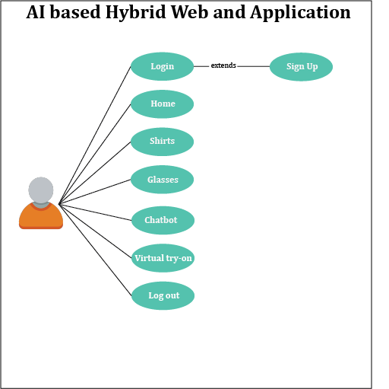

Figure 2.1: Main Use Case Diagram

Figure 2.1 shows the use case diagram of the whole application where user can sign up, login, view variety of glasses and shirts, virtually try-on products, get help from chatbot, saved snaps and logout.

**2.6.1 Sign up:**

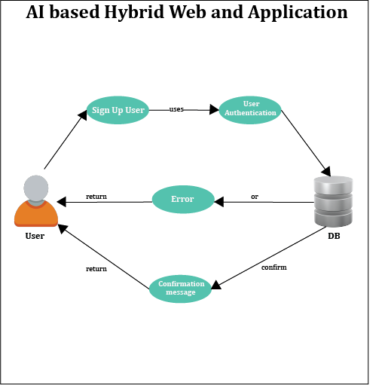

Figure 2.2: Sign Up Use Case Diagram

Figure 2.2 shows the use case diagram of the signup, user will add email and password in the signup screen and account will be created.

**2.6.2 Log in:**

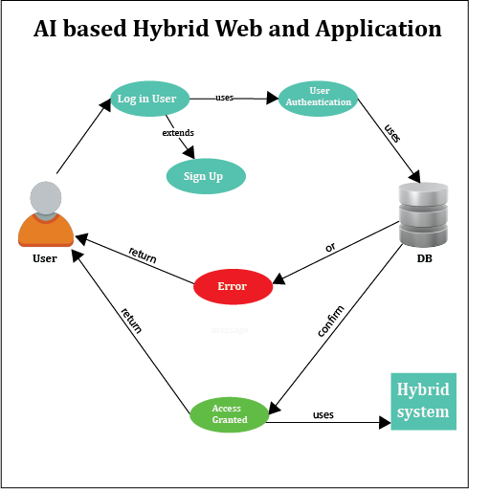

Figure 2.3: Login Use Case Diagram

Figure 2.3 shows the use case diagram of the login, user will enter email and password in the login screen and application access will be granted to user.

**2.6.3 Home Page:**

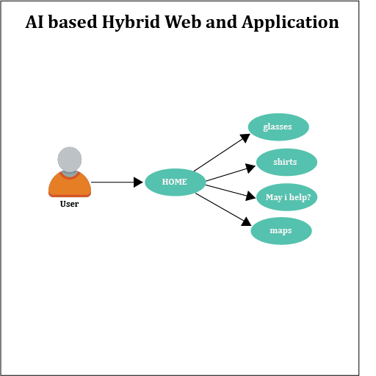

Figure 2.4: Home Use Case Diagram

Figure 2.4 shows the use case diagram of the home, user can view varieties of glasses on clicking glasses button, user can view varieties of shirts on clicking shirts button, user can get help from simple chatbot ,user can get location on map of outfit.

**2.6.4 Glasses Page:**

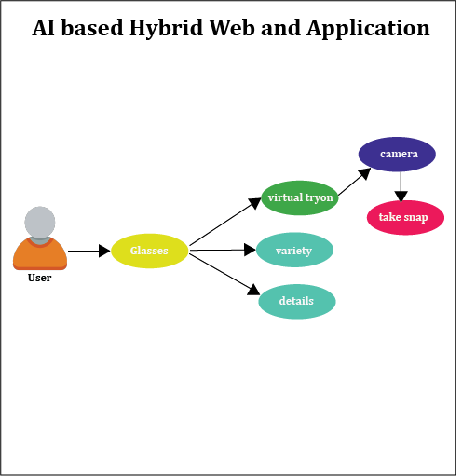

Figure 2.5: Glasses Use Case Diagram

Figure 2.5 shows the use case diagram of the Glasses option, user can view variety of glasses, get detail of each, can try virtually, get try on snaps as well.

**2.6.5 Shirts Page:**

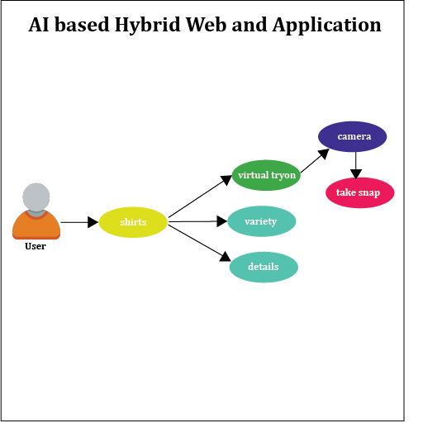

Figure 2.6: Shirts Use Case Diagram

Figure 2.6 shows the use case diagram of the Shirts option, user can view variety of shirts, get detail of each, can try virtually, get try on snaps as well.

**2.6.6 Simple Chatbot:**

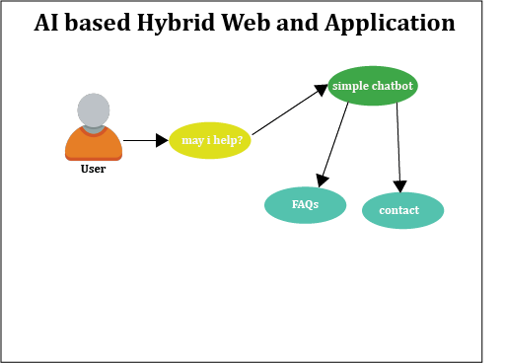

Figure 2.7: chatbot Use Case Diagram

Figure 2.7 shows the use case diagram of the chatbot, user can get help from chatbot by getting answers of FAQs and by making contact between user and admin via call etc

**2.6.7 Snaps:**

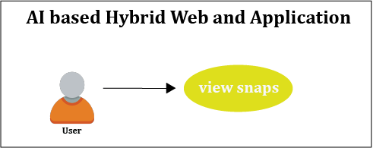

Figure 2.8: Snap Use Case Diagram

Figure 2.8 shows the use case diagram of the snap, user can take snapshots of virtually tried glasses or shirts.

**2.6.8 Log out:**

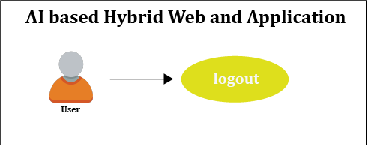

Figure 2.9: Log out Use Case Diagram

Figure 2.9 shows the use case diagram of the logout, user can logout from the application.

Table 2.1: Sign up Use Case Description Table

|  |  |
| --- | --- |
| **Use Case Field** | Description |
| **Use Case Name** | Signup |
| **Use Case ID** | AA-01 |
| **Actors** | User and application |
| **Preconditions** | Application must be installed in device Open application.  User must have account on application A decent internet connection should be available on the device. |
| **Use Case Description** | New user will sign up on the application. |
| **Input Summary** | Step: 01 Click on signup.  Step: 02 On the sign-up screen, the user will fill in the essential information.  Step: 03 The user will double-check that the data entered is correct.  Step: 04 In the end click on the sign-up button |
| **Output Summary** | New user will be sent to the login screen. |

In Table 2.1, use case of sign up is described in detail. It includes all steps and constraints to be followed during the user will sign up on the application.

Table 2.2: Login Use Case Description Table

|  |  |
| --- | --- |
| **Use Case Field** | Description |
| **Use Case Name** | Login |
| **Use Case ID** | AA-02 |
| **Actors** | User and application |
| **Preconditions** | Application must be installed in device Open application.  User must have account on application  A decent internet connection should be available on the device. |
| **Use Case Description** | New user will sign up on the application. |
| **Input Summary** | Step: 01 On the login screen, the user will enter the username/email and password. Step: 02 Click on Login button |
| **Output Summary** | User will be sent to the home screen |

In Table 2.2, use case of login is described in detail. It includes all steps and constraints to be followed during the user will login on the application.

Table 2.3: Home Use Case Description Table

|  |  |
| --- | --- |
| **Use Case Field** | Description |
| **Use Case Name** | Home |
| **Use Case ID** | AA-03 |
| **Actors** | User and application |
| **Preconditions** | User must be login to the application |
| **Use Case Description** | User will view different functionalities which are available in the home screen. |
| **Input Summary** | On the home screen user will see many features like Glasses variety, shirts variety, simple chatbot helper, map of store and a logout button. |
| **Output Summary** | Successfully viewing the features which are available on the home screen. |

In Table 2.3, use case of home is described in detail. It includes all steps and constraints to be followed during the user interaction with home screen on the system.

Table 2.4: Outfit Glasses Variety Use Case Description Table

|  |  |
| --- | --- |
| **Use Case Field** | Description |
| **Use Case Name** | Outfit Glasses Variety |
| **Use Case ID** | AA-04 |
| **Actors** | User and application |
| **Preconditions** | Home screen must be opened. |
| **Use Case Description** | Outfit brand glasses variety show. |
| **Input Summary** | On the glasses screen user will see variety of glasses, user will able to open each image of glasses in separate page and view the product with 360 angle vision, uses also able to try pretended glasses virtually on face and get snaps. |
| **Output Summary** | User try glasses virtually and have images. |

In Table 2.4, use case of Outfit Glasses Variety is described in detail. It includes all steps and constraints to be followed during the user will have outfit glasses page on the application.

Table 2.5: Outfit Shirts Variety Use Case Description Table

|  |  |
| --- | --- |
| **Use Case Field** | Description |
| **Use Case Name** | Outfit Shirts Variety |
| **Use Case ID** | AA-05 |
| **Actors** | User and application |
| **Preconditions** | Home screen must be opened. |
| **Use Case Description** | Outfit brand shirts variety show. |
| **Input Summary** | On the shirts screen user will see variety of shirts, user will able to open each image of shirt in separate page and view the product with 360 angle vision, uses also able to try pretended shirt virtually on body and get snaps. |
| **Output Summary** | User try shirts virtually and have images. |

In Table 2.5, use case of Outfit Shirts Variety is described in detail. It includes all steps and constraints to be followed during the user will have outfit Shirts page on the application.

Table 2.6: Chatbot Use Case Description Table

|  |  |
| --- | --- |
| **Use Case Field** | Description |
| **Use Case Name** | May I help? |
| **Use Case ID** | AA-06 |
| **Actors** | User and application |
| **Preconditions** | Home screen must be opened. |
| **Use Case Description** | User can get answers of FAQs through system. |
| **Input Summary** | User have to click on May I help? Button and select the pretented question or if user have another query user can call through app. |
| **Output Summary** | User get answer of question. |

In Table 2.6, use case of Chatbot feature is described in detail. It includes all steps and constraints to be followed during the user will get help from chatbot on the application.

Table 2.7: Virtual Try-on Use Case Description Table

|  |  |
| --- | --- |
| **Use Case Field** | Description |
| **Use Case Name** | Virtual try-on |
| **Use Case ID** | AA-07 |
| **Actors** | User and application |
| **Preconditions** | Home screen must be opened |
| **Use Case Description** | Can try product virtually |
| **Input Summary** | Step: 01 Click on the try-on button.  Step: 02 On the screen, the camera will open.  Step: 03 Stay in front of camera.  Step: 04 A 3d plane will be pop up on the screen. |
| **Output Summary** | User will try glasses and shirts on screen and can save it. |

In Table 2.7, use case of Virtual try-on is described in detail. It includes all steps and constraints to be followed during the user will try products virtually on the application.

Table 2.8: Logout Use Case Description Table

|  |  |
| --- | --- |
| **Use Case Field** | Description |
| **Use Case Name** | Logout |
| **Use Case ID** | AA-08 |
| **Actors** | User and application |
| **Preconditions** | User has already logged in the application. |
| **Use Case Description** | This use case explains how a user may log out of an application after logging in. |
| **Input Summary** | Step: 01 User will click on logout button on the screen |
| **Output Summary** | The system will log out the user and redirect it to the login screen of the application. |

In Table 2.8, use case of logout is described in detail. It includes all steps and constraints to be followed during the user will logout on the application.

**Chapter 3**

**System Design**

**3.1 System Architecture**

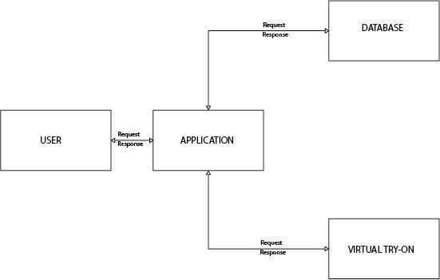

Figure 3.1: Basic Architecture

Figure:3.1 depicts the application’s fundamental design, which includes two main modules: Virtual Try-on and database. The application will identify and comprehend its surroundings in the actual world before employing artificial intelligence to fulfil the application’s goal.

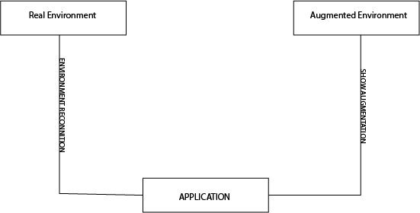

Figure 3.2: Environment Interaction

Figure:3.2 depicts the interplay between the actual and augmented environments. It has a relationship with each other because it places an AI plane in the actual world and performs activities in accordance with it.

**3.2 High Level Design**

**3.2.1 Data Flow Diagram**

In terms of inputs and outputs, a data flow diagram depicts how data is handled by a system. The concentration, as its name suggests, is on the flow of information, namely where it originates from, where it flows, and how it is kept.

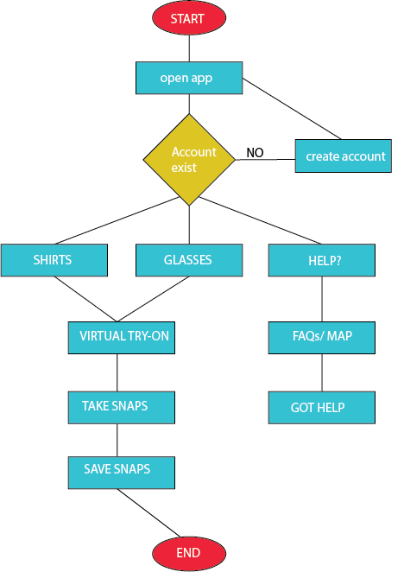

Figure 3.3: Dataflow Diagram

In figure: 3.3 the data flow diagram of our application is given how data flow in the system.

**3.2.2 Activity Diagram**

The sequence of actions is represented using an activity diagram. Activity diagrams depict the process from start to end, highlighting the multiple choice routes that exist in the activity’s development of events.

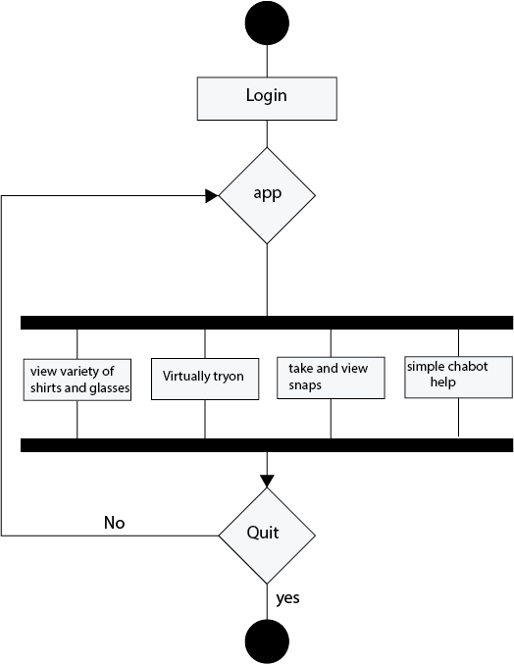

Figure 3.4: Activity Diagram

Figure 3.4 activity diagram shows how users can perform actions in the application. First of all, the user will open the application on mobile and login to the application, the home screen will appear where he/she can get variety of products, get help from chatbot, try products virtually and also save or view snapshots.

**3.3 Virtual Try-on Workflow**

**3.3.1 Glasses virtual try-on:**

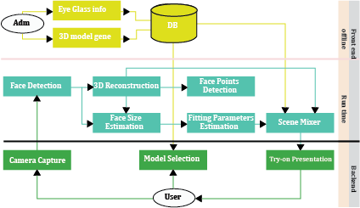

Figure 3.5: Workflow Diagram

Figure 3.5: shows that how virtual try-on glasses feature of glasses will work.

**3.3.2 Shirts virtual try-on:**

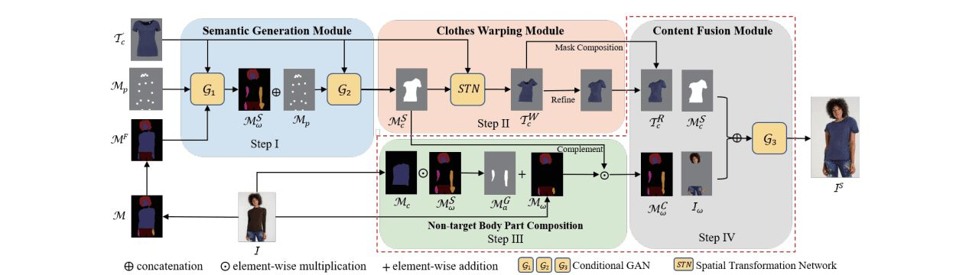

Figure 3.6: Workflow Diagram

Figure 3.5: shows that how virtual try-on shirts feature of glasses will work.

**3.4 Sequence Diagram**

The most frequent type of interaction diagram is a sequence diagram, which shows how messages are sent between many lifelines.

**3.4.1 Signup Sequence Diagram**

If the user has provided the sign-up information in the right order, an account will be established; otherwise, the system will show the user an error notice. The sign-up process is depicted in the diagram below.

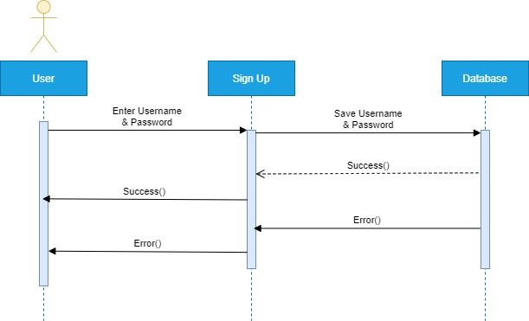

Figure 3.7: Signup Sequence Diagram

Figure: 3.7: shows the sequence diagram of the signup operation of the application.

**3.4.2 Login Sequence Diagram**

If the user has provided the correct login information means email and password, the system will allow them to access the application; otherwise, an error notice will be displayed.

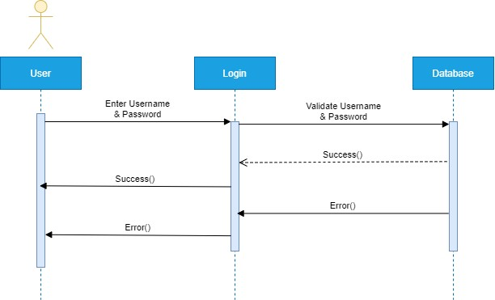

Figure 3.8: Login Sequence Diagram

Figure: 3.8 shows the sequence diagram of the login operation of the application.

**3.4.3 Glasses/shirts screen Sequence Diagram**

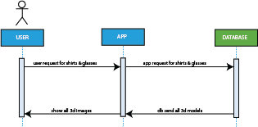

Figure 3.9: glasses/shirts screen Sequence Diagram

Figure: 3.9 shows the sequence diagram of the glasses and shirts look in system.

**3.4.4 Virtual Try-on screen Sequence Diagram**

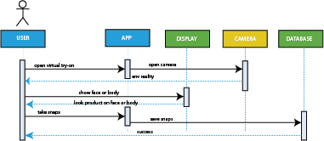

Figure 3.10: Virtual try-on Sequence Diagram

Figure: 3.10 shows the sequence diagram of the virtual try-on in system.

**3.4.5 Log out Sequence Diagram**

If the user is already logged, he or she can log out from the application.

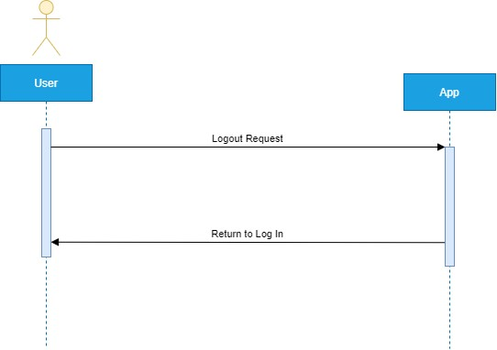

Figure 3.11: Logout Sequence Diagram

Figure: 3.11 shows the sequence diagram of the logout operation of the application.

**Chapter 4**

**System Implementation**

Implementation is the process of turning a concept into reality. The system implementation is the programming and development of an algorithm into a software component.

**4.1 Tools and Technologies**

The following tools and technologies were used to create this application:

• Android Studio

• Vs Code

• Jupyter Notebook

• Firebase

• ML/DL

**4.2 Libraries / Packages**

The following libraries and packages are used by our application:

• AR Core

• cupertino icons: 0.1.2

• flutter rating bar: 4.0.0

• latlong2: 0.8.1 53

• dio: 4.0.4

• flutter map: 0.14.0

• flutter dotenv: 5.0.2

• firebase storage: 10.2.9

• uuid: 3.0.6

• image picker: 0.8.4+11

• flutter lints: 1.0.4

• fluttertoast: 8.0.9

• firebase auth: 3.3.14

• firebase core: 1.14.1

• Numpy

• OpenCV

• imutils

• dlib

• pytorch

• flask

• MLkit

**4.3 Development Environment / Language used:**

Flutter will be used to implement the frontend of our application, while Dart will be used to implementing the backend for application and python will be used to implement virtual try-on feature.